**NOTE: This is an official document by Indexademics. Unless otherwise stated, this document may not be accredited to individuals or groups other than the club IDX, nor should this document be distributed, sold, or modified for personal use in any way.**

**IDX G9 MATH H STUDY GUIDE ISSUE**

**By Samuel**

1. **Trigonometric Ratio in Acute Triangles**

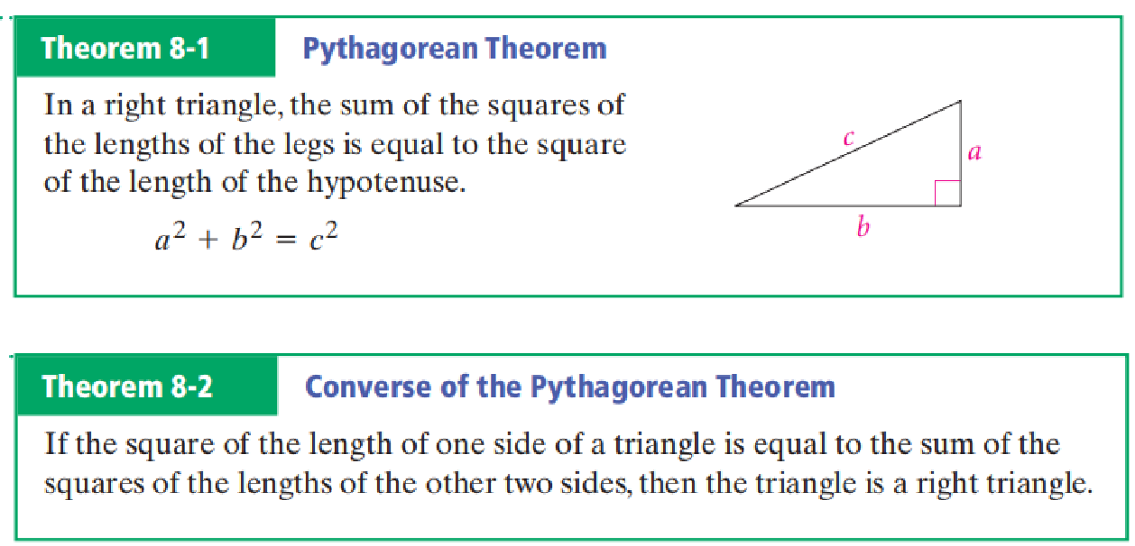

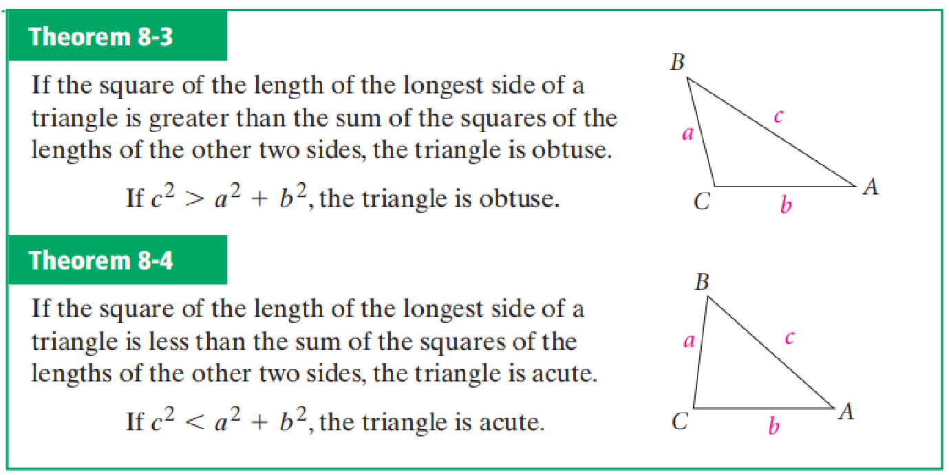

**Special Right Triangles**

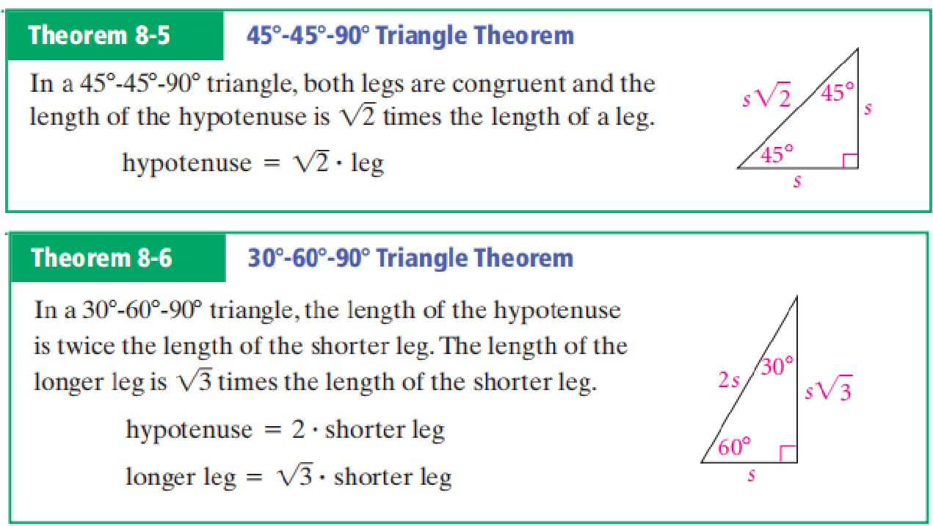

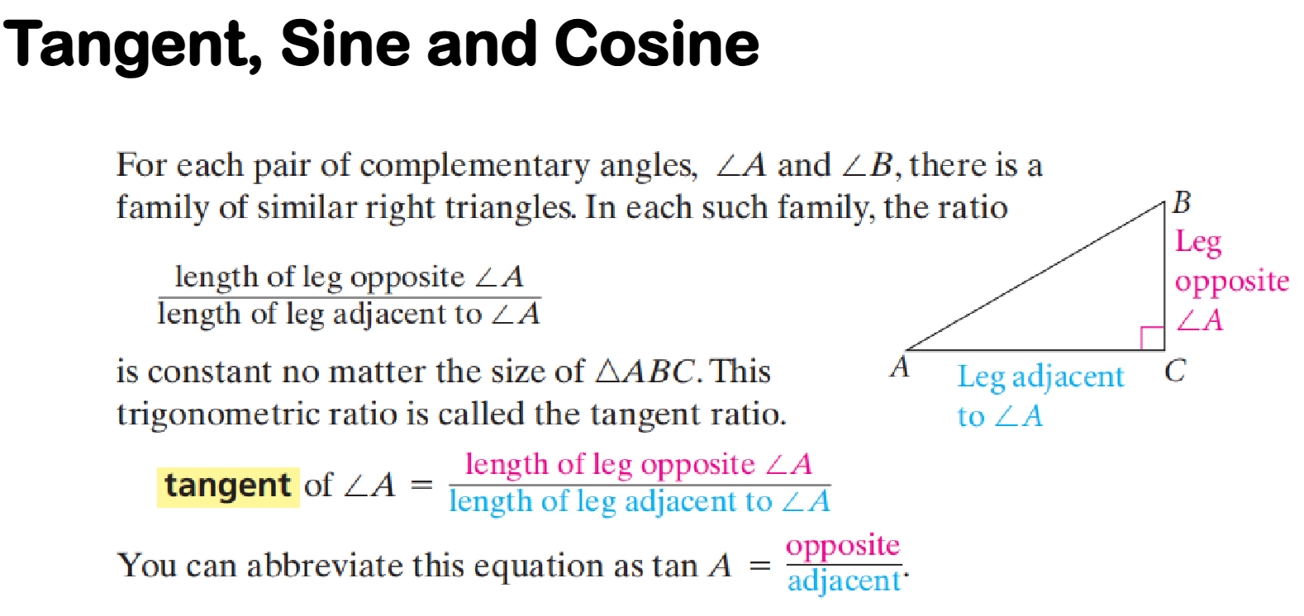

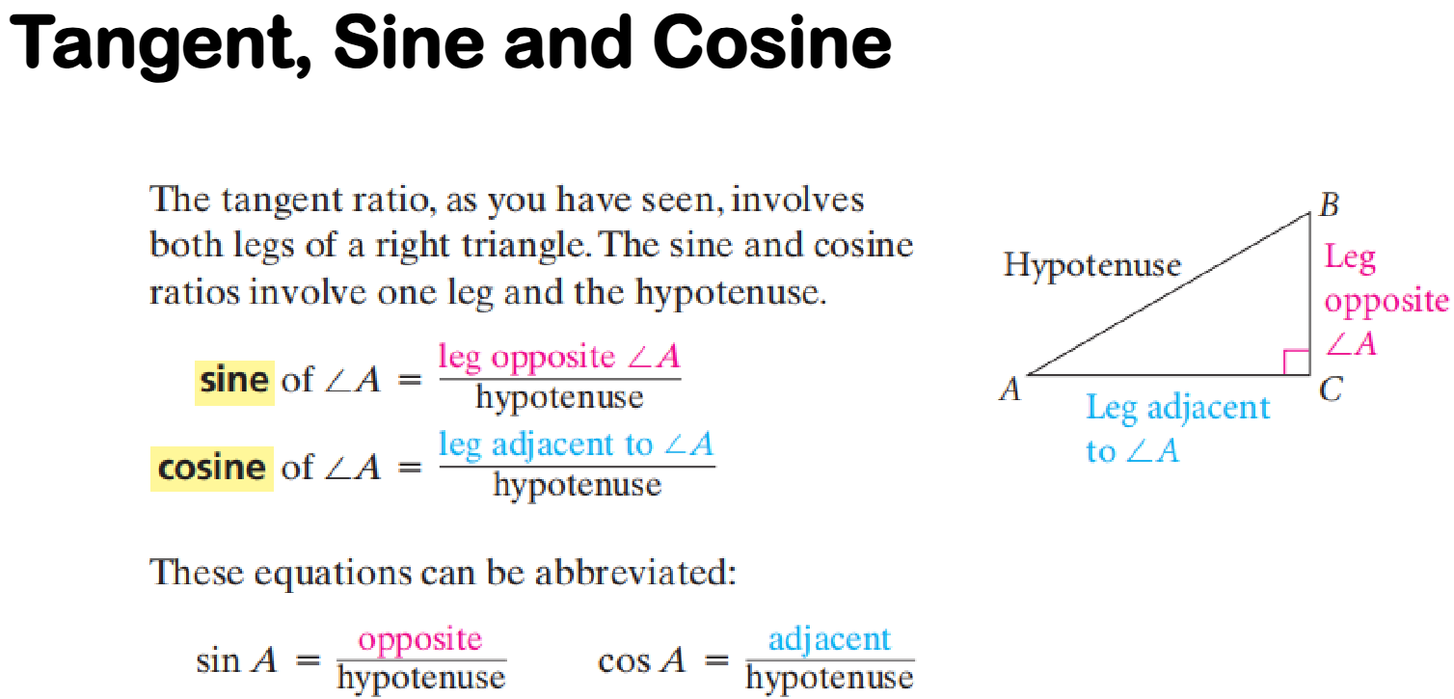

1. **Perimeter and Areas of Polygons**

